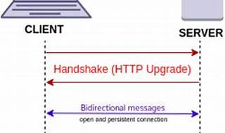

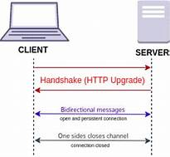

Explore

Certainly! [In a nutshell, **WebSockets** create a persistent, bidirectional communication channel between a web browser and a server, allowing real-time data exchange without the need for repeated HTTP requests or page reloads1](https://www.techopedia.com/definition/websocket).

Here are **five free reference links** where you can learn more about WebSockets:

1. [**Techopedia**](https://www.techopedia.com/definition/websocket): Provides a comprehensive definition, mechanics, and examples of WebSockets.
2. [**Wikipedia**](https://en.wikipedia.org/wiki/WebSocket): Covers the standardized WebSocket protocol and its use in web applications.
3. [**Ably Realtime**](https://ably.com/topic/websockets): Explains WebSocket as a technology for bidirectional, full-duplex communication between clients and servers.
4. [**Metana**](https://metana.io/blog/what-are-websockets-and-how-do-they-work/): Offers insights into bidirectional communication, persistence, and real-time applications using WebSockets.

Feel free to explore these resources to deepen your understanding of this powerful communication technology! 🚀